**Deming Calibration Analysis**

Analysis of sensor data from Deming calibration test indicates strong agreement and high precision between sensors. While there is slight variance in reported PM2.5 concentration, especially at higher values, there is overall strong agreement between sensors over time. Test points to unreliability in PurpleAir local storage, in which for all sensors there are data-gaps, though these gaps are relative small, and all sensors recorded roughly the same volume of data.

Figure - Records per sensor. Data was written to the SD card about every 2 minutes, though this is inconsistent. There are data gaps for all sensors in which it appears data was not being written to the SD card.

Plotting PM2.5 records over time indicates that there is slight variance, but overall strong agreement between sensors across time. Note data gaps.

Figure - PM2.5 concentration per-sensor over time. Readings roughly every 2-seconds.

There is slight variance in reported PM2.5 values. Relative strong agreement in mean recorded PM2.5, with larger variance observed in max recorded value (+- 10 ug/m3 PM2.5).

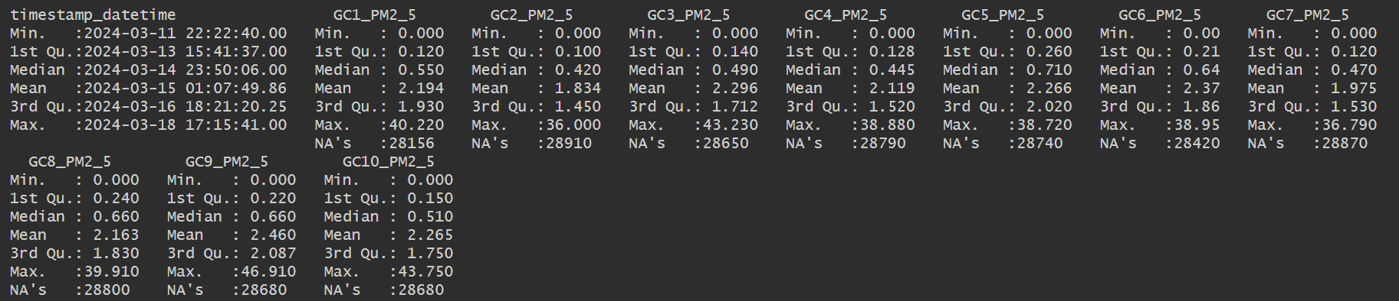

Figure - Data summary.

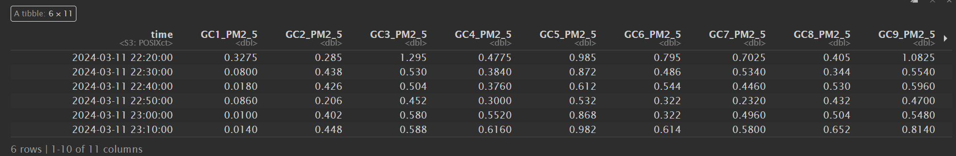

Figure - Subset of data aggregated to 10-minute time weighted average. Note slight variance (+-1 ug/m3 PM2.5) between sensors.

Pairwise correlation tests indicate high precision across sensors.

Figure - Pairwise correlation tests between all sensors. Data aggregated to 10-minute time weighted average.